Report of " दिल्लीकोकूड़ेसेआज़ादी- Swacchata Campaign"
Conducted from 04.09.2025 – 02.10.2025

Name of the Institution: Sanjay Gandhi Memorial Hospital (SGMH), S-block Mangolpuri, Delhi
Date: 05.09.2025
Activity Conducted: Hand Hygiene Promotion –demonstration and practice of WHO 7 steps.
Hand hygiene promotion –demonstration of WHO 7 steps
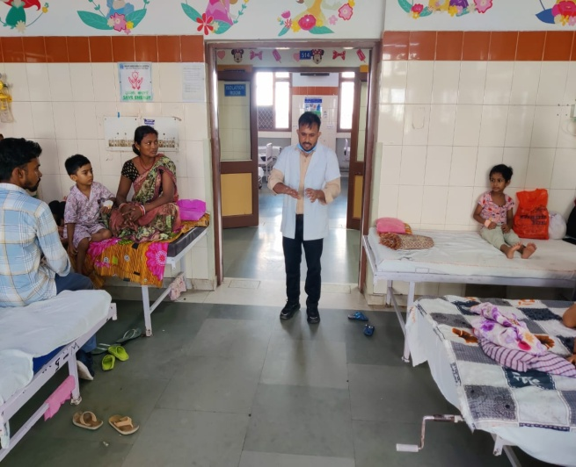 | 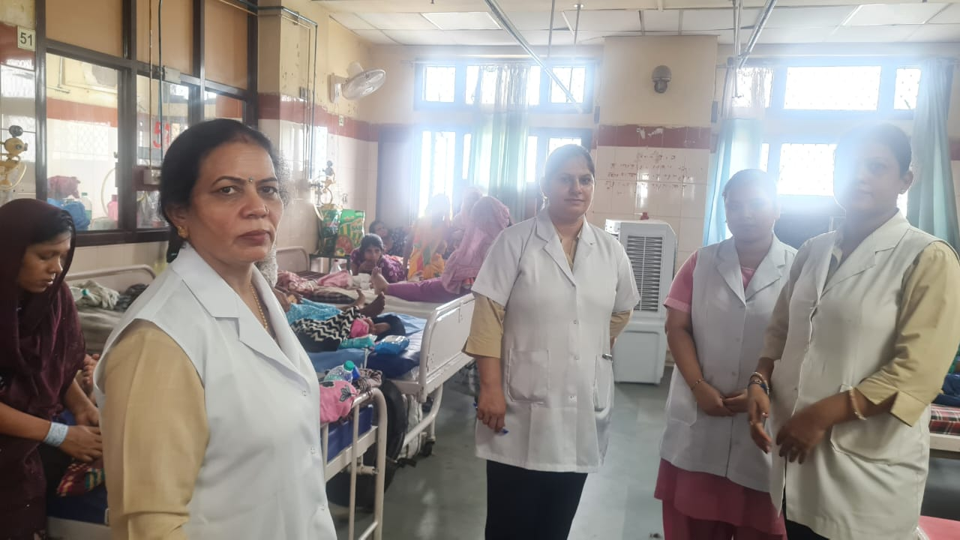
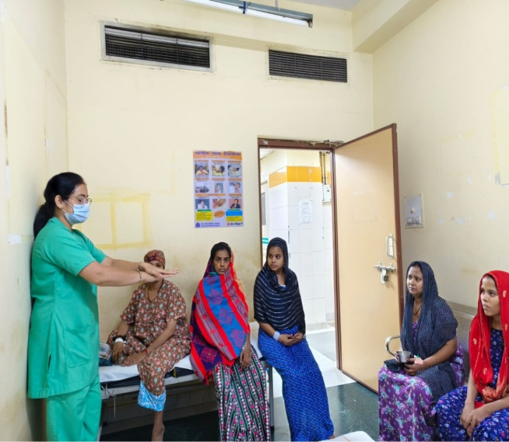 | 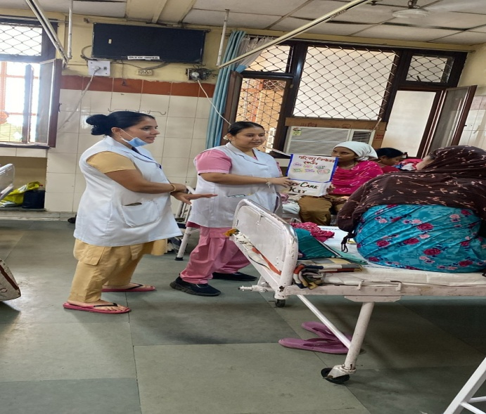
Details (50–100 words): As part of the Swacchata Campaign under the initiative “दिल्लीकोकूड़ेसेआज़ादी, A hand hygiene promotion session was conducted, focusing on the demonstration and practice of the WHO 7 steps of handwashing. Participants were guided through each step, emphasizing proper technique to ensure effective germ removal. The session included a live demonstration followed by hands-on practice, reinforcing the importance of hand hygiene in infection prevention. Overall, the activity enhanced awareness and encouraged adherence to global hygiene standards.
SIGNATURE: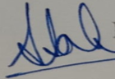
H.O.O./ DMS (Admin)
NAME: DR.SUMITA SAHA KANWAR

