Report of " दिल्लीकोकूड़ेसेआज़ादी- Swacchata Campaign"
Conducted on 24.09.2025

Name of the Institution: Sanjay Gandhi Memorial Hospital (SGMH), S-block Mangolpuri, Delhi
Date: .24.09.2025
Activity Conducted: laundry and linen audit.
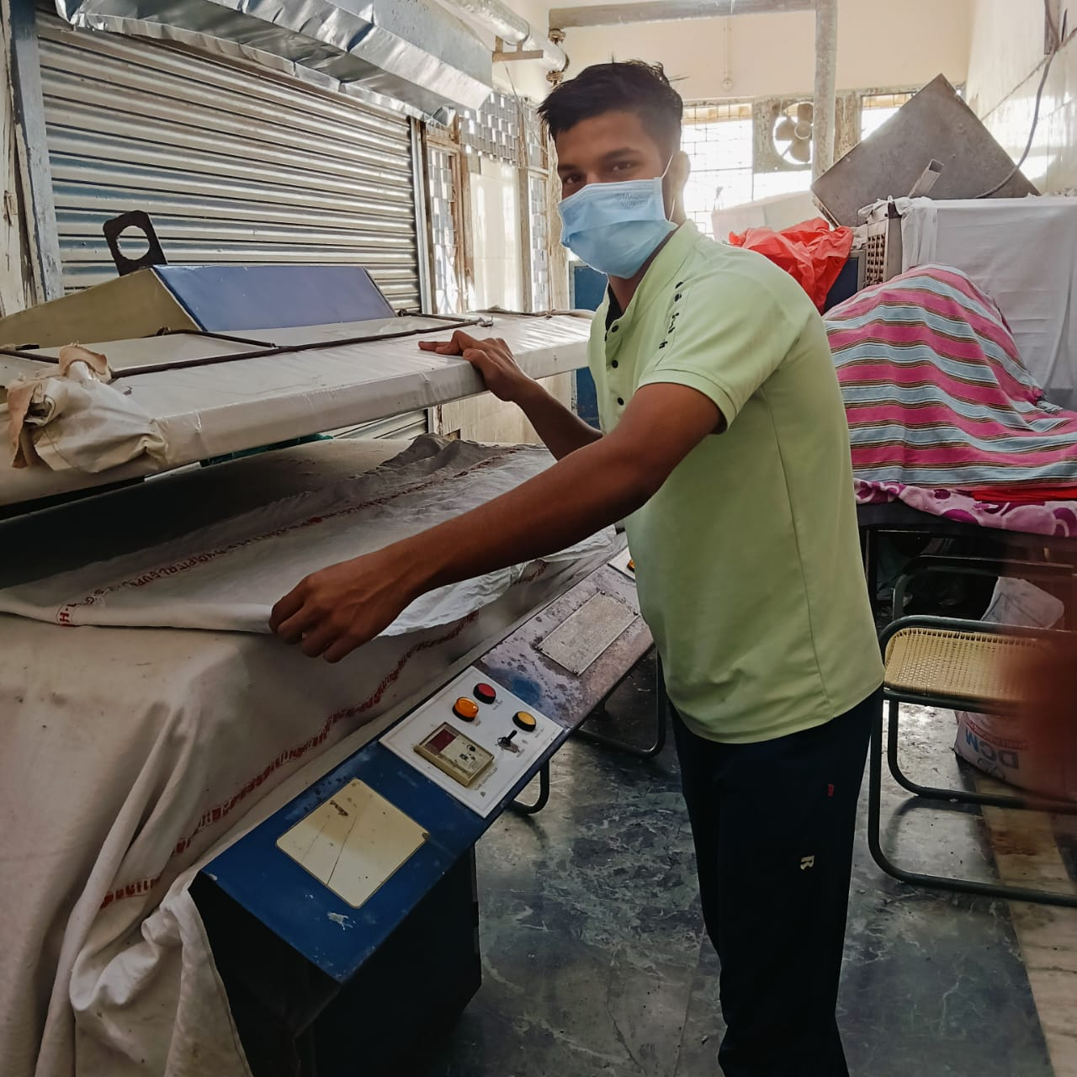 | 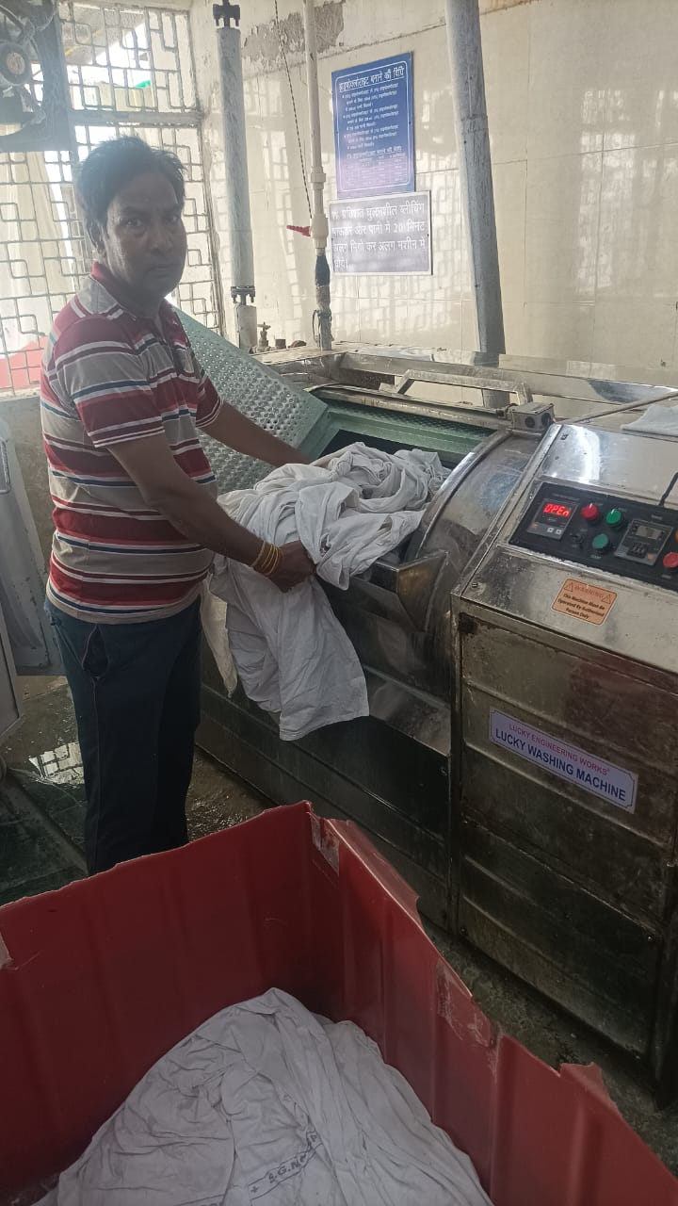
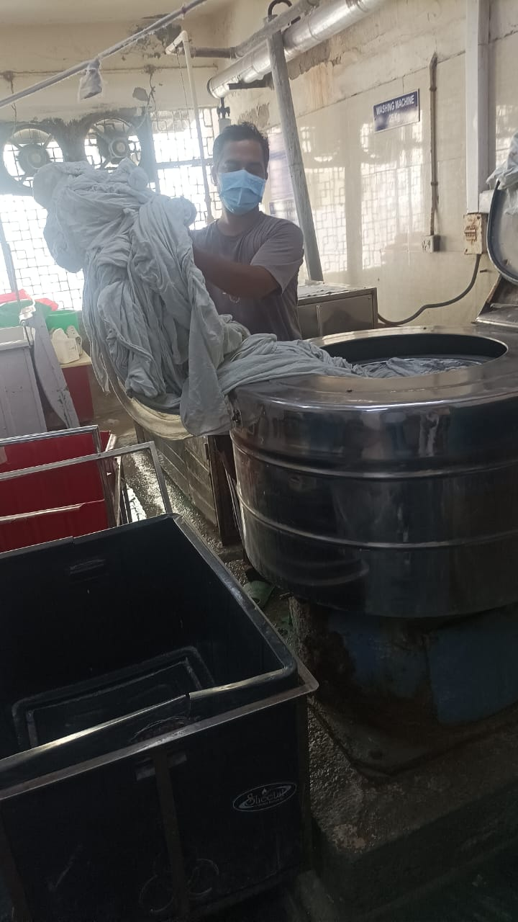 | 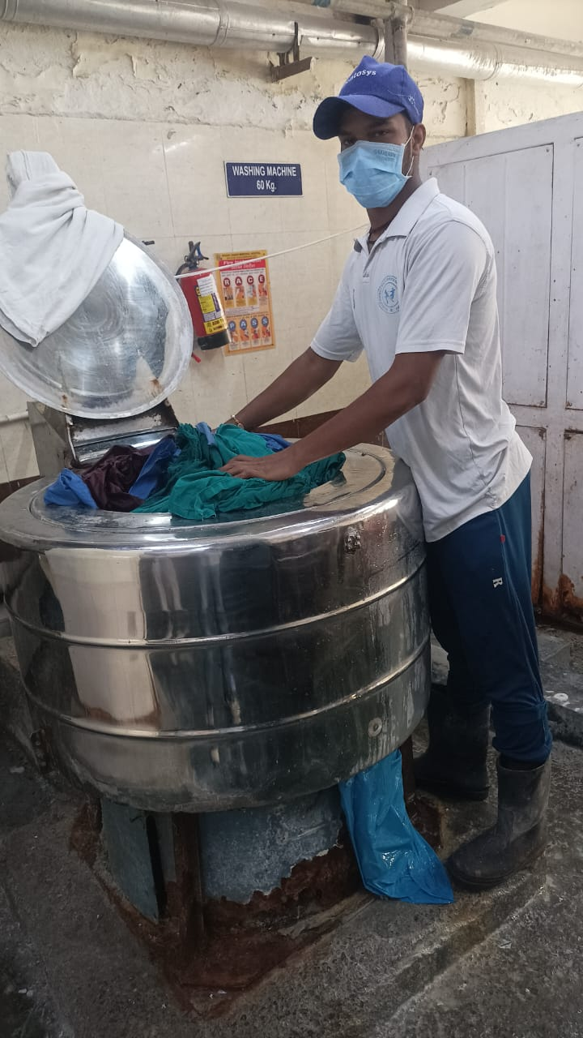
Details (50–100 words): A Laundry and Linen Audit were conducted under the Swachhata Campaign to ensure proper hygiene and infection control. The audit reviewed collection, segregation, washing, and storage of hospital linen, checking for cleanliness, proper disinfection, and adherence to safety protocols. Areas like the laundry room and linen stores were inspected for waste management and overall maintenance. Staff was guided on best practices for handling soiled linen and maintaining records. The activity helped identify gaps, reinforced standard operating procedures, and promoted a cleaner, safer environment for patients and healthcare workers.
.
SIGNATURE: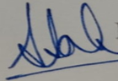
H.O.O./ DMS (Admin)
NAME: DR.SUMITA SAHA KANWAR

