Report of " दिल्ली को कूड़े से आज़ादी- Swacchata Campaign"
Conducted from 04.09.2025 – 02.10.2025
Name of the Institution: Sanjay Gandhi Memorial Hospital (SGMH), S-block Mangolpuri, Delhi
Date: 04.09.2025
Activity Conducted: Cleanliness Drive and checking of toilet functionality and odor in hospital premises.
Before: public toilet | After: public toilet
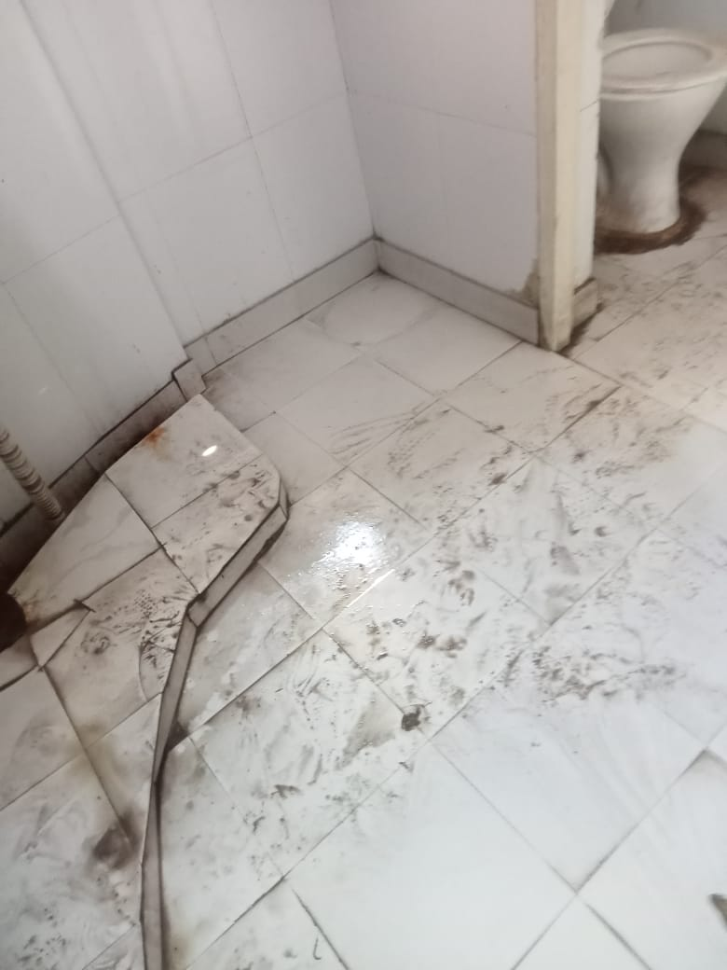 | 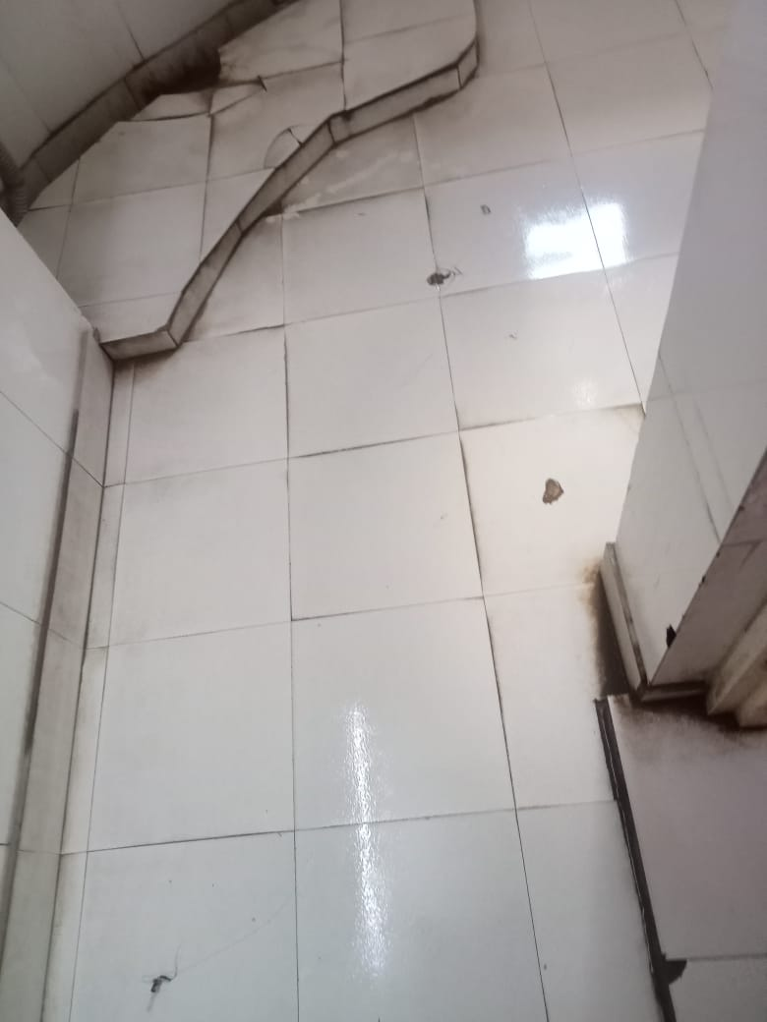
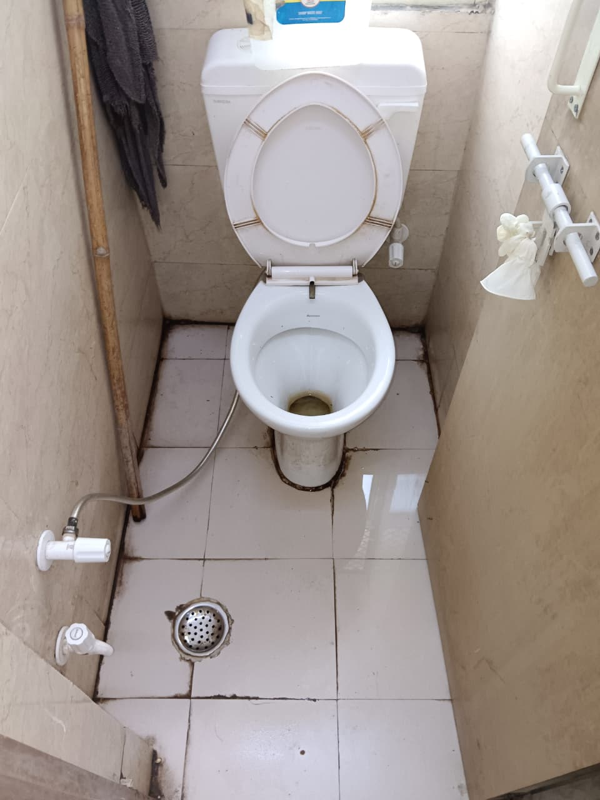 | 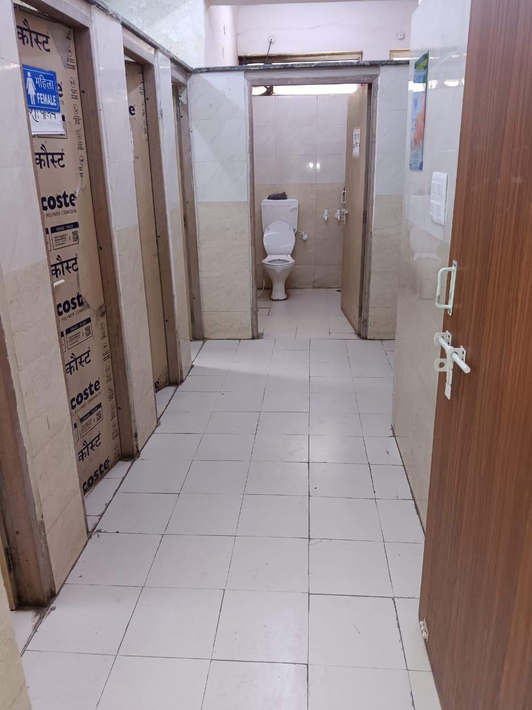
Before: staff toilet | After: staff toilet
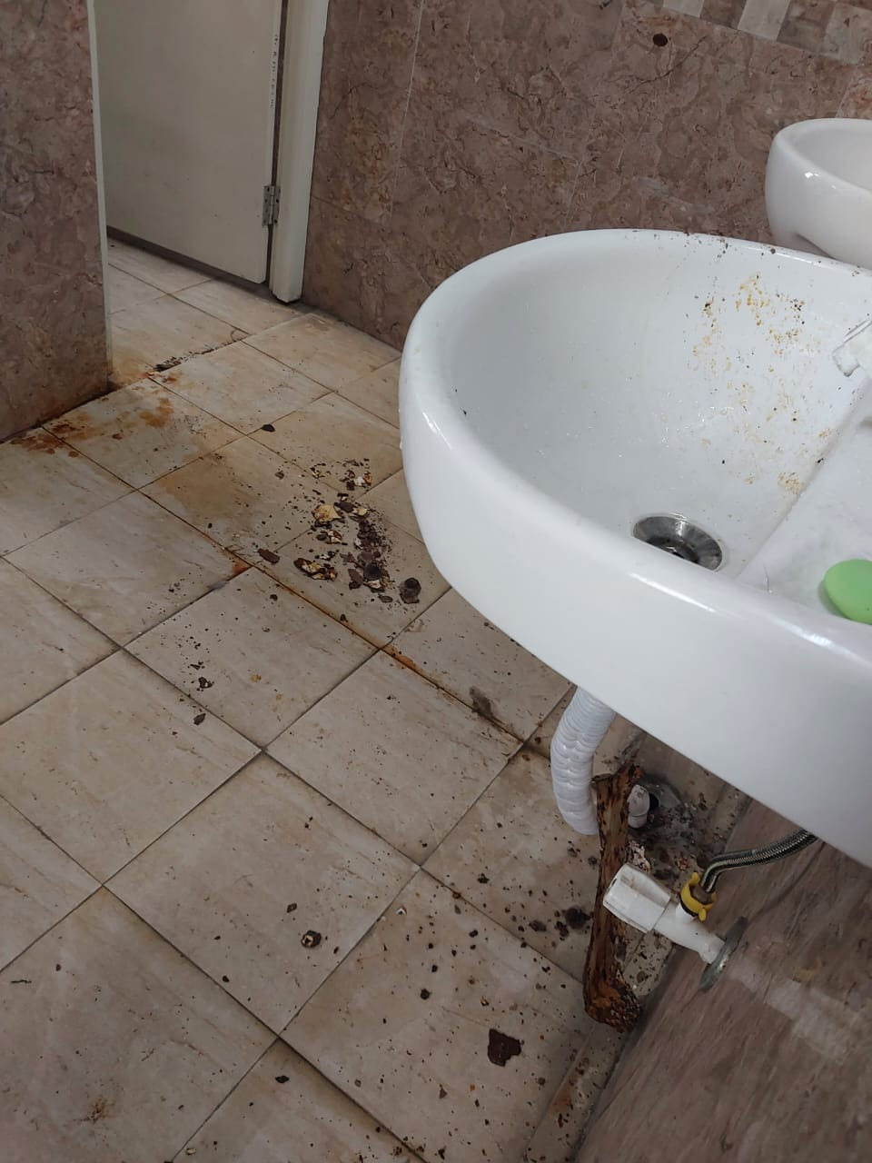 | 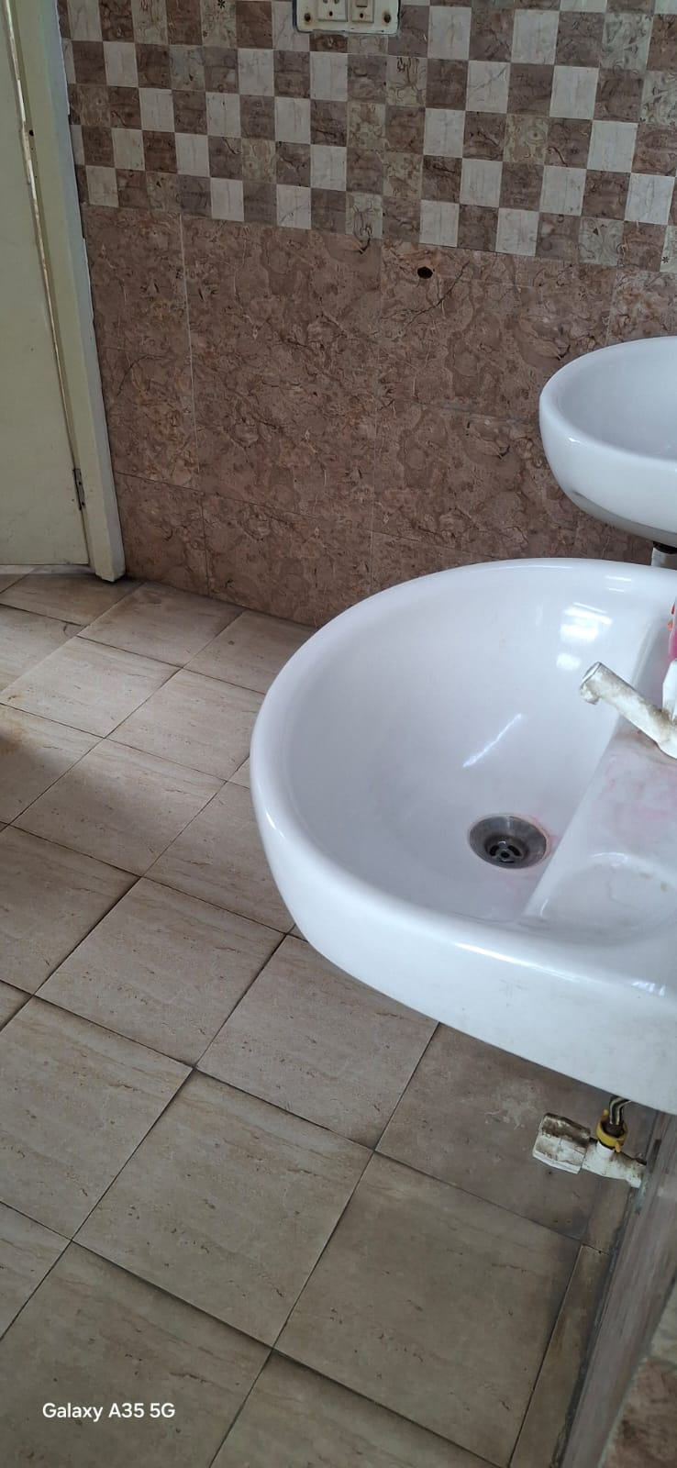
Details (50–100 words): As part of the Swacchata Campaign, Sanjay Gandhi Memorial Hospital organized a cleanliness drive on 4th September 2025 under the initiative “दिल्ली को कूड़े से आज़ादी”. Inspection of toilet functionality and odor was checked and corrective action was taken .The activity aimed to maintain hygiene and cleanliness in the hospital premises.
Photos of the activity have been labeled and attached for identification.
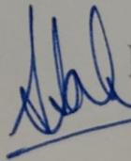
SIGNATURE:
H.O.O._Deputy Medical Superintendent (Admin)
NAME: Dr. Sumita Saha Kanwar

