Report of " दिल्ली को कूड़े सेआज़ादी- Swacchata Campaign"
Conducted from 01.08.2025 – 31.08.2025

Name of the Institution: Sanjay Gandhi Memorial Hospital (SGMH), S-block Mangolpuri, Delhi
Date: 12.08.2025
Activity Conducted: infection control committee review meeting was done. Along with infection control related gaps BMW gaps were also discussed and some gaps are either closed or under process to close them.
Photos displaying review meeting of infection control committee.
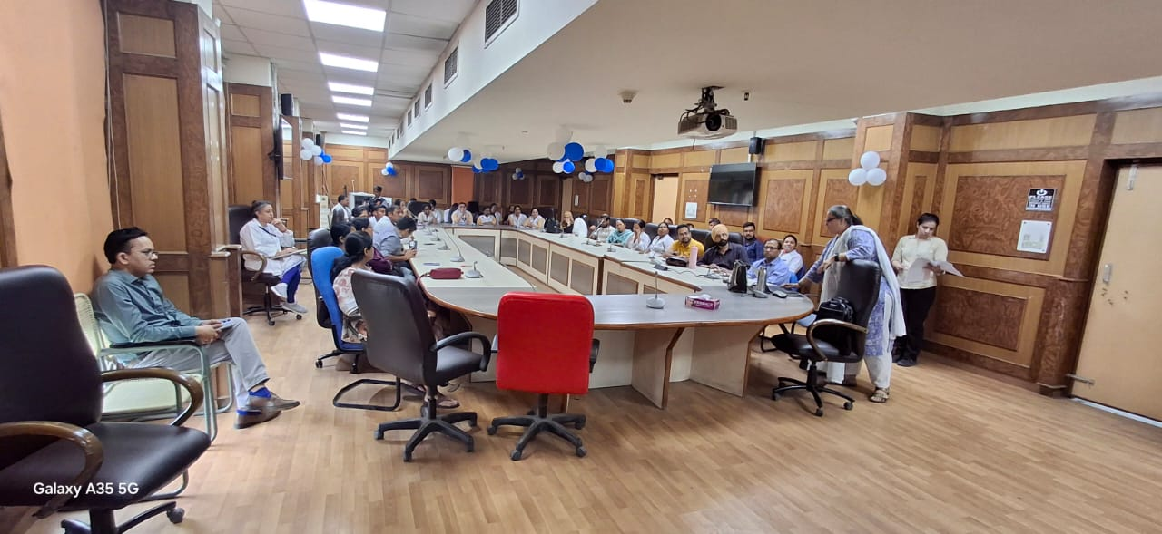
Before | After
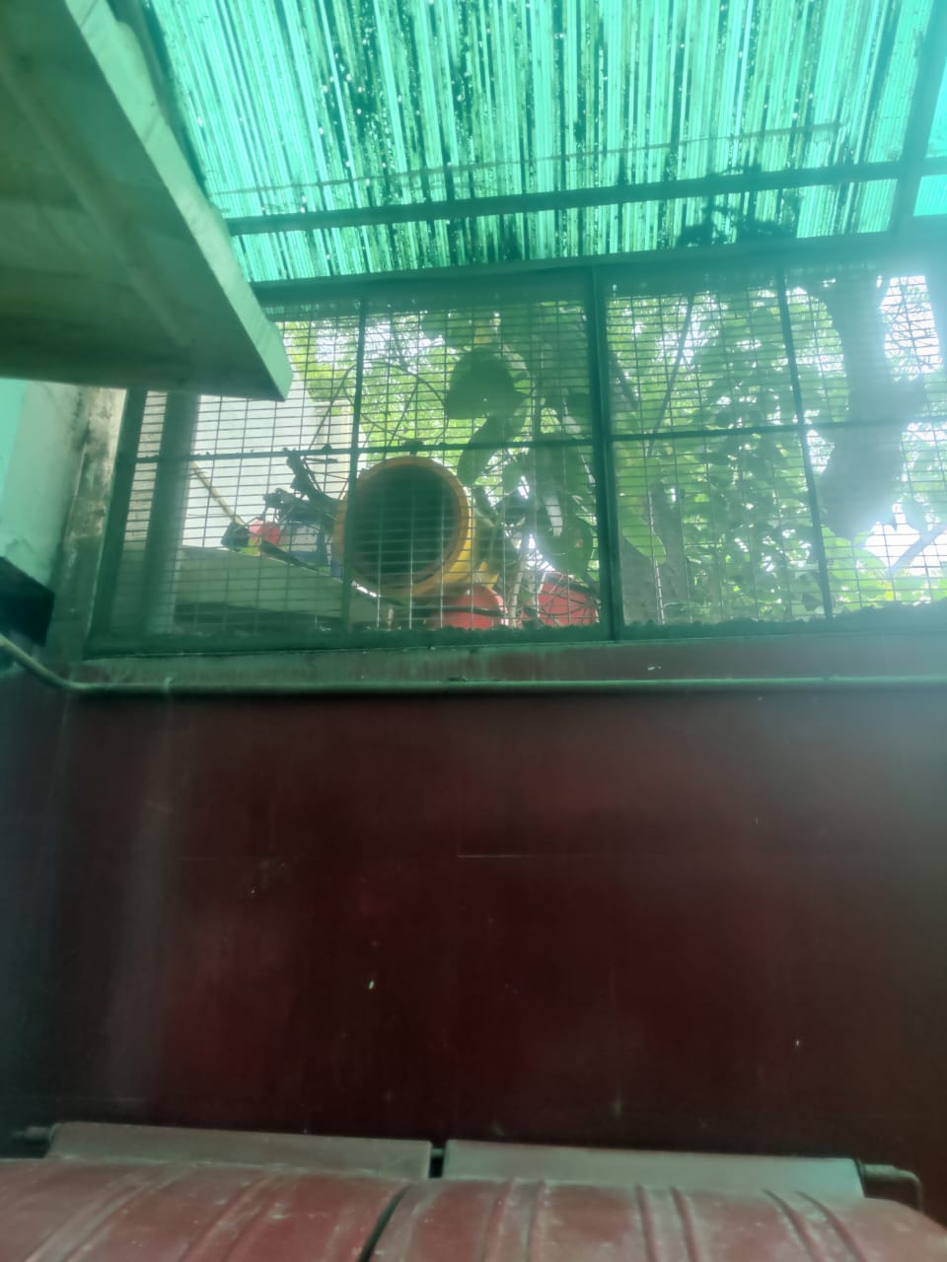 | 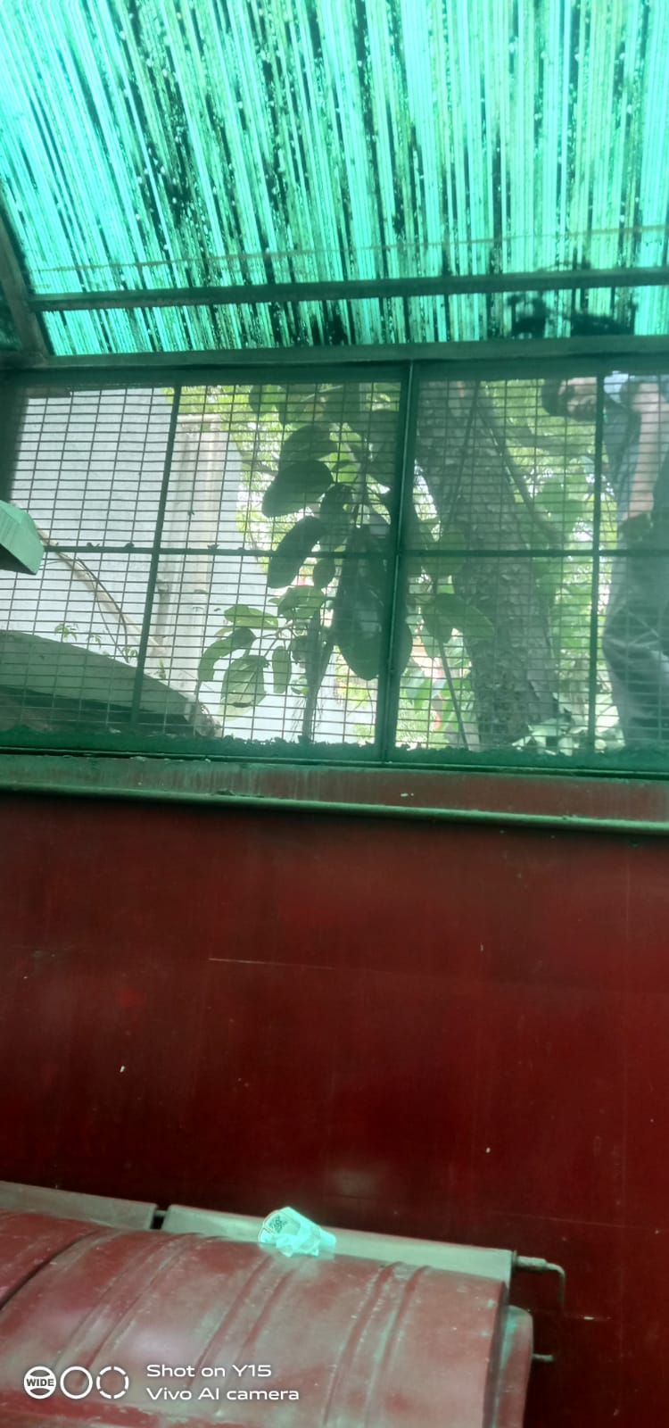
Removing of junk material from BMW STORAGE unit (one of the gap is closed)
Mom of the meeting of BMW & Infection Control
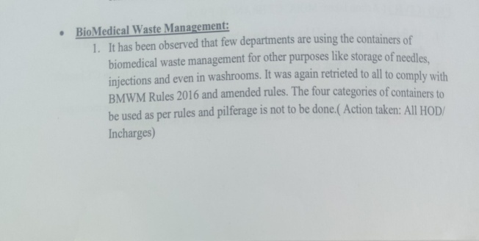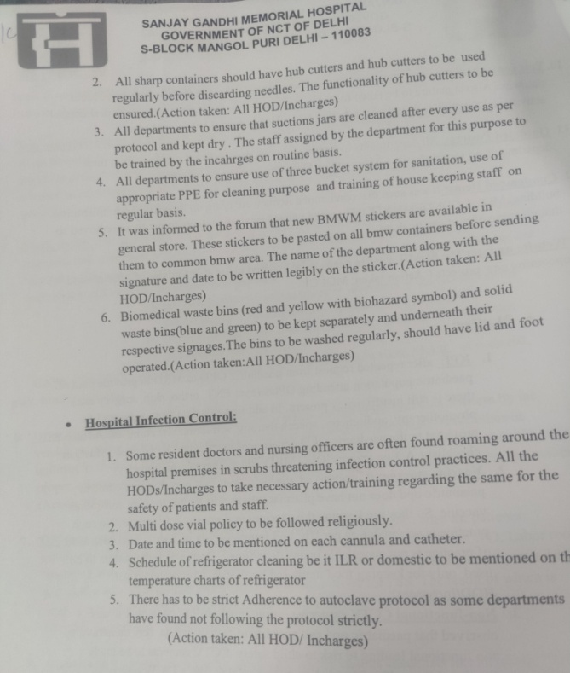 |  | 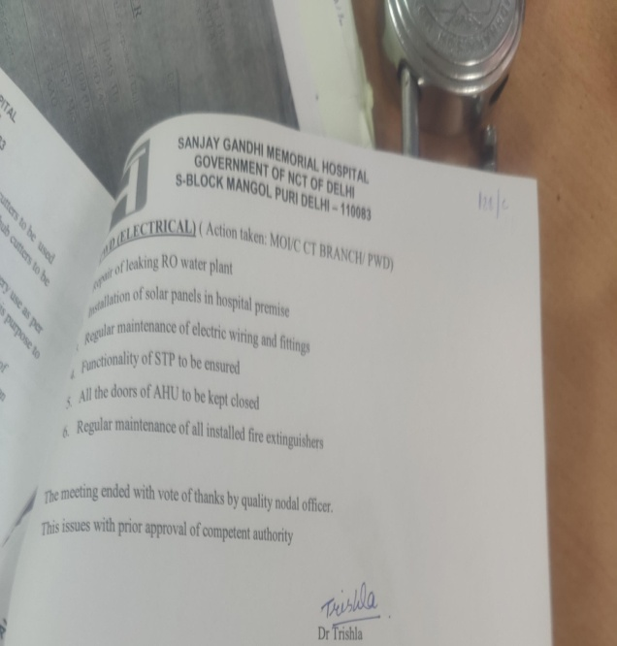
Details (50–100 words): As part of the Swacchata Campaign under the initiative “दिल्ली को कूड़े सेआज़ादी, an infection control meeting was held at SGMH to reinforce key protocols. Discussions included strict adherence to the multidose vial policy to prevent contamination and ensure safe usage. The cleaning schedules for the ILR and pharmaceutical fridge were reviewed, emphasizing regular maintenance and documentation. Additionally, all departments were reminded to strictly follow the autoclave protocol to ensure proper sterilization of medical equipment.

SIGNATURE: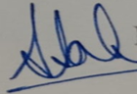
H.O.O./ DMS (Admin)
NAME: DR.SUMITA SAHA KANWAR

